**Sample questions for POE**

1. Write a C# program for **String Manipulations** (All string related functions) without built-in functions and C# program for String Manipulations (All string related functions) with built-in functions
2. Write a C# program on **Classes and Objects** Properties for a student class (Reg_no, name, DOB) and calculate the age of a student from DOB with constructor
3. Write a C# program on **Classes and Objects** Properties for a Employee class (Emp_id, post, salary) and calculate the annual taxes from salary with constructor overloading
4. Write a C# program for **Single Inheritance** for base class University with fields university_name, total_students and derived class College with fields college_name, total_enrollment for Education Management System demonstrating the “base” keyword
5. Write a C# program for **Multiple Inheritance** for base class Bank with fields bank_name, branch and interface customer with fields cust_name, age those are derived by class Account with fields account_number, balance for Banking System.
6. Write a C# program for **Multilevel Inheritance** for base class Grandparent with fields name, age and derived class Parent with field education which is again derived by Child class with fields marital_status for a family tree demonstrating the “is” and “as” keywords
7. Write a C# program demonstrating **abstract class** for Person with fields name, age that is derived by Employee with fields designation, salary in Company with fields company_name, total_emp to calculate Annual Tax
8. Write a C# program demonstrating **Interfaces** for Person with fields name, age that is derived by Student with fields roll_no, marks to display grade
9. Write a C# program define a Point type derived from **the Object class**.
10. Write a C# program demonstrating **Polymorphism** for Person with fields name, age that is derived by Adhar_card with fields Social Security Number demonstrating **“virtual” and “override” keyword**
11. Write a C# program demonstrating **Polymorphism** for Country fields country_name, population that is derived by State with fields state_name, population to demonstrate **“new” keyword in context of method overriding**
12. Write a C# program demonstrating **Polymorphism** for Student Result to display grade to demonstrate **“sealed” keyword**
13. Write a C# program WAP to demonstrate **Handling Exceptions using try-catch-finally blocks** that is defined to handle “ArithmeticException” and catches “DivideByZeroException” errors.
14. Write a C# program to demonstrate **to avoid exception handling in case of Usage Errors** with example of the Object.Equals(Object) method that throws “NullReferenceException” exception
15. Write a C# program to demonstrate **the “throw” keyword** for a string extension String.IndexOf(String, Int32) method to throw an “ArgumentNullException” exception.
16. Write a C# program to demonstrate **creating and defining Custom Exceptions** to define a “NotPrimeException” exception that is thrown when a client tries to retrieve a sequence of prime numbers by specifying a starting number that is not a prime.
17. Write a C# program demonstrating **multithreading** to display numbers (1st thread to display 1 to 10 and 2nd thread to display from 11 to 20)
18. Write a C# program to demonstrate Matrix multiplication using **MultiThreading**
19. Write a C# program demonstrating **Simple delegate** that declares a delegate”Del” and the associated method “MultiplyNumbers” which have the same signature to multiply numbers 1 to 5 with 2.
20. Write a C# program demonstrating **Multicast delegate** that declares a delegate ”Operation” and the associated methods “Add”, “Subtract” and “Multiply” which have the same signature using the + operator and the – operator.
21. Write a C# program to create a **Windows Form App** take two numbers as input and calculate addition, subtraction, division and multiplication

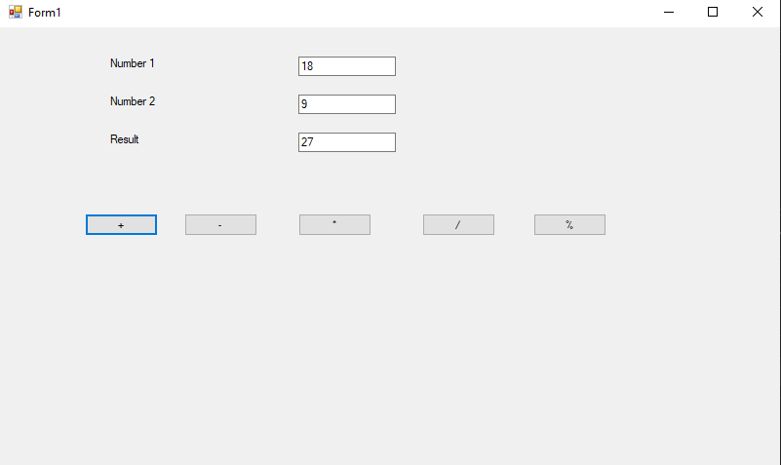

1. Write a C# program to create a **Windows Form App** take two numbers as input and calculate addition, subtraction, division and multiplication

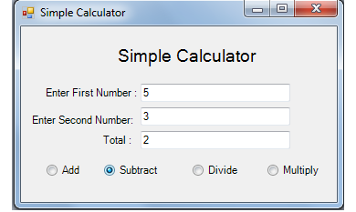

1. Write a C# program to create a **Windows Form App** take two numbers as input and calculate addition, subtraction, division and multiplication

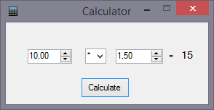

1. Write a C# program to create a **Windows Form App** for Math Quiz

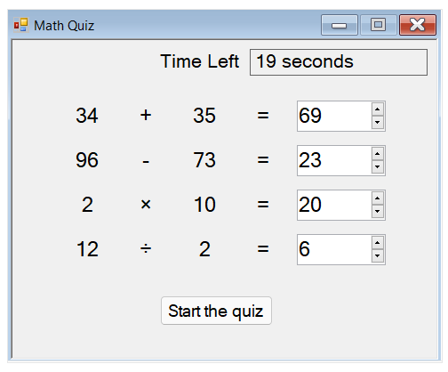

1. Write a C# program to create a picture viewer **Windows Forms app**

